The Schools.
The Vanessa Grant School is a residential school for mentally handicapped children aged 6 to about 14 or 15 years. The Gogar Primary school is nearby and has about 600 day pupils.
See website for more details: http://www.vanessagranttrust.org

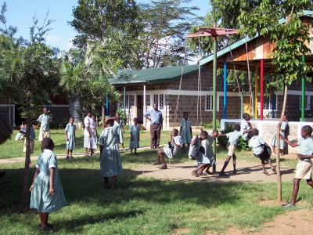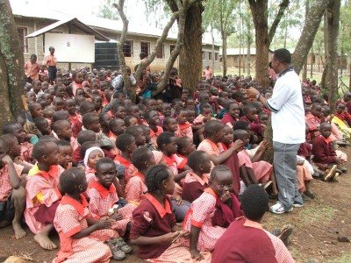
VGS children at play Gogar Primary School
Accommodation.
you will need to pay for food and normal living costs such as soap etc.
Vegetables are available locally as is milk, but meat needs to come from
Nakuru and is more expensive, fairly similar to the UK. There is no rental
for accommodation which is very basic. A furnished house, 2 bedrooms,
sitting room, 2 showers, tiny kitchen with gas rings, electricity and a fridge. Basic furniture is in place. It is important to sleep under a

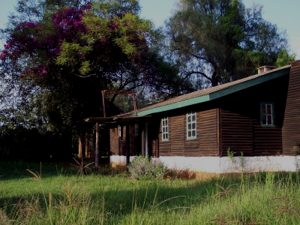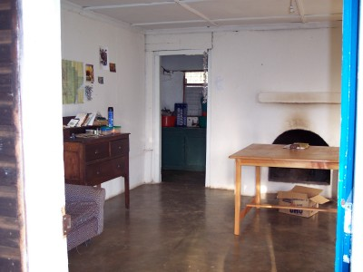
The Dugout 1 The Sitting Room and tiny kitchen 1

Mosquito net. We can provide these, though if you are planning to travel it is a good idea to have your own. They are readily available here. We do not take prophylactics, but it is a good idea to consult your doctor. If you are proscribed meflaquine or Lariam, be very careful as it can have violent side effects. Nobody here touches the
stuff though it is commonly prescribed by doctors in the UK.

I strongly suggest that you give yourselves time to explore this country as
it has so much to offer and once you have become accustomed to the people
and way of life you will have the confidence to see lots of places.

Insurance.
At the risk of being boring, you must put good medical insurance in place as
hospitalisation is expensive. It is also a good idea to have a local
evacuation option so that if you need to be flown to Nairobi, it can be done
with the confidence that you can afford it! Never forget that you are coming
to the third world. There is an adequate hospital in the nearest town Nakuru about 30 minutes drive away.

It is also a good idea to bring a mobile phone that is not tied to a network
in the UK, so that you can buy a local SIM card. There is coverage in Rongai. If you do not have such a phone, it is worth considering buying one here. A least you can text home and ring us if you have a problem anywhere. You would also then be able to buy a SIM card wherever you are in the world and keep in touch.

The other school I am involved in is the Gogar Primary School where there are about 500 children 6-14 years old run by a wonderful Head called Sister Hiltrude. I know she would welcome volunteer teachers.

This is less than ten minutes from the farm by bicycle. At the moment we have four used by volunteers.

Very much hoping that I have not put you off!!

The best way to find out more about the VGS is to visit the website. See below.

Term dates are from; early January to mid April, May to early August and early September to early November. The schools are very close together and it might be possible to work part time in each. Everyone is very flexible here.

You would need to find all your living costs and neither school is in any position to pay any salary. You would need good medical insurance and be happy living on your own. There is a small community on the farm, so you would have some social contact, but it would be lonely. I have always suggested that people come with a friend, which makes it very much easier.

We ask volunteers to pay £500 into the Vanessa Grant School Trust account. This is to cover any unforeseen costs that may arise. The balance of the funds is available for projects within the school where you are working and will enable you to make some form of material donation to the school, perhaps in the form of playground equipment, books etc. These projects should be undertaken in conjunction with the Head of the school and the trustees of the VGS to ensure that funds are put to best use.

You would also need to sign a waiver form as the attached and organise comprehensive medical insurance for yourself including emergency evacuation cover.

JEO July 2012

